Unit 2.1 Graded Assignment

Name: Hamza Mohammad Asim
Employee#: 2303.KHI.DEG.014
Collaborated with: Saad Sameer Khan (2303.KHI.DEG.034)

Python code snippet with incorrect formatting.

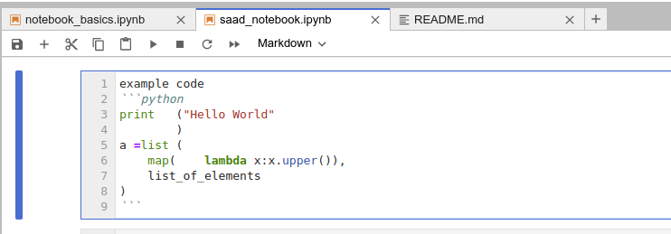

Running blacken-docs to correct it.
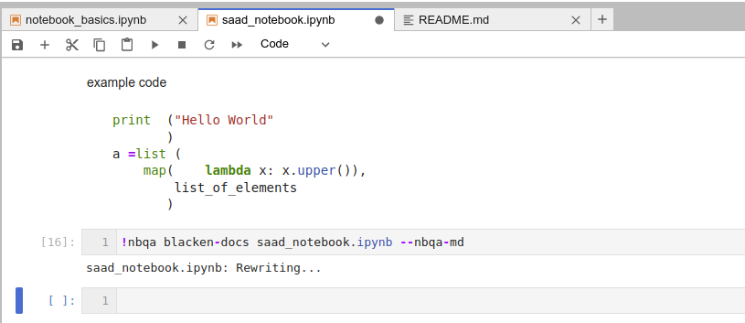

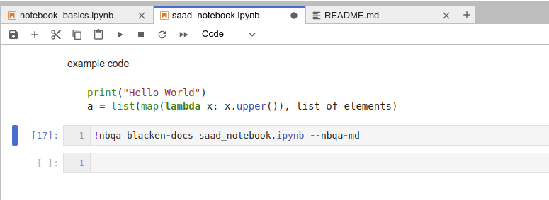

Code has now been formatted successfully.

